**AHMED HAMED ALY**

18308279

DATE: 19/OCT/2018

LAB: LG35/36

TIME: 4PM TO 6PM

**Introduction**

The experiment consisted of four main parts,

(A) Connecting a circuit using the circuit diagram provided in the question;

(B) Observing the output of the circuit on the oscilloscope and calculate the cut-in voltage from the diodes;

(C) Replacing one of the diodes to an LED from the first circuit diagram;

(D) Plot the input and output waveforms with the LED and without the LED.

There was a couple of factors I had to consider before starting the experiment. These included,

Using working apparatus that has been tested before and won’t cause an error in my result;

Calibrated the oscilloscope using the probes and making sure that line was aligned with the middle;

Understood what a diode is and how it functioned in comparison to the rest of the circuit. A diode acted as a one-way gate that didn’t allow current to follow background.



Diode

**Objective**

The objective of the experiment is to estimate the cut-in voltage of the diodes and the cut-in voltage of the circuit with and without an LED instead of a diode.

What I expected to notice on the oscilloscope when I am estimating the cut-in voltage of the diodes is a normal sin wave instead the top and bottom of the wave is cut-in due to the diodes. I expected the graph to look like the image below; 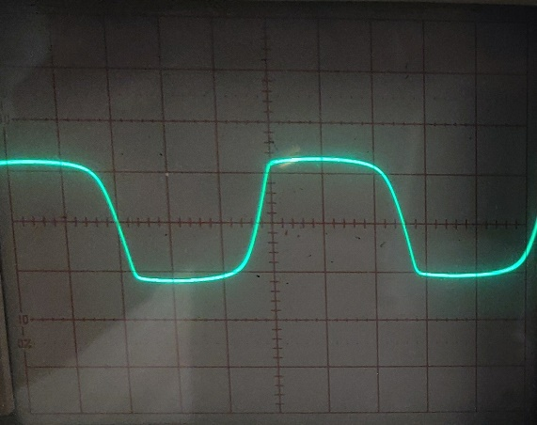

For the second part of the experiment I expected to notice only a cut-in voltage at the top of the wave for without the LED but for with the LED I expected to have a bigger cut-in voltage like the images below;

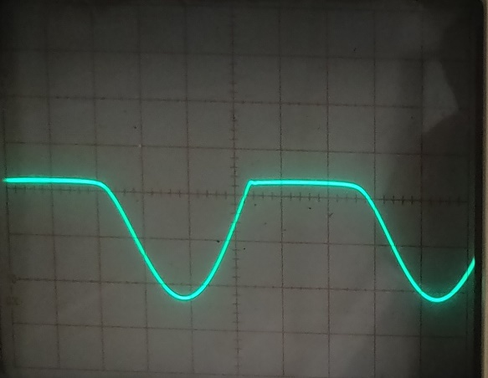 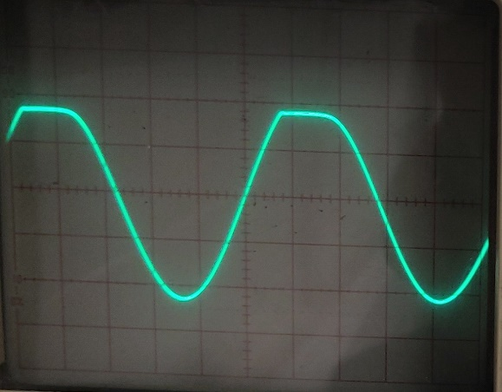

With the LED Without the LED

**Apparatus**

The apparatus used for the experiment (shown below) were vital to producing the results I acquired from the experiment.

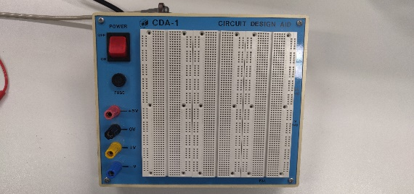 

Breadboard 2 x Diodes

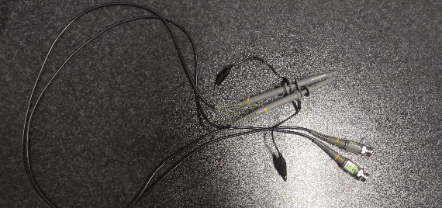 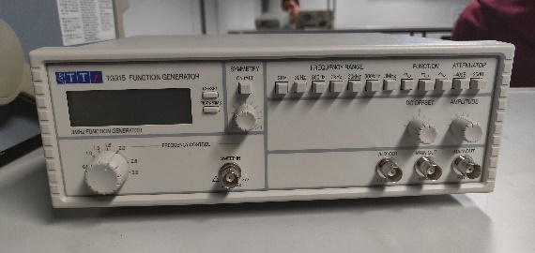

Probes ` Function Generator

 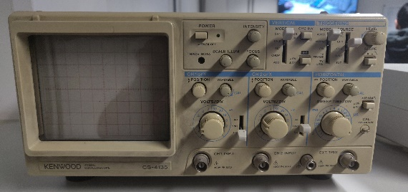

Light Emitting Diode (LED) Oscilloscope

 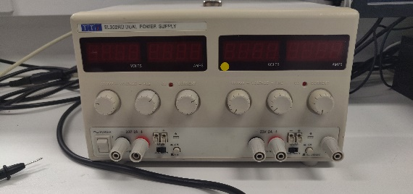

2.2KΩ Resistor Power Supply

**Method**

1. Connect the circuit (**CIRCUIT 1**) in the diagram shown below.

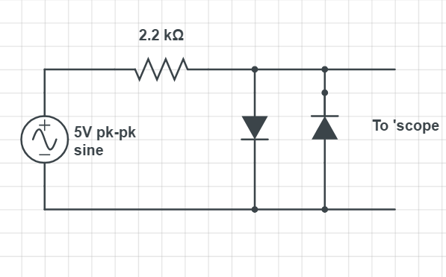

1. We observed the oscilloscope until we noticed a cut-in voltage, that was being displayed on the oscilloscope, where the two diodes were creating a cut in the sin-wave.
2. Connect the circuit (**CIRCUIT 2**) in the diagram show below by replacing the diode by an LED.

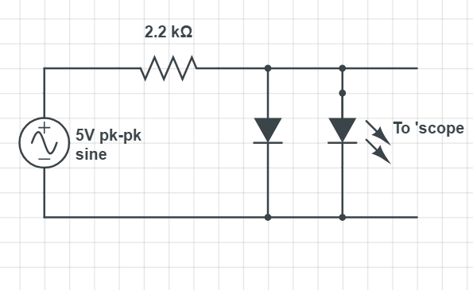

1. I recorded the input and output waveforms for both without the LED and with the LED and estimated the cut-in voltage of the LED and observed the different waveforms.

**Data/Graph**

**Circuit 1:**

The output waveform:

|  |
| --- |
| Cut-in Voltage |
| ≈0.7V |

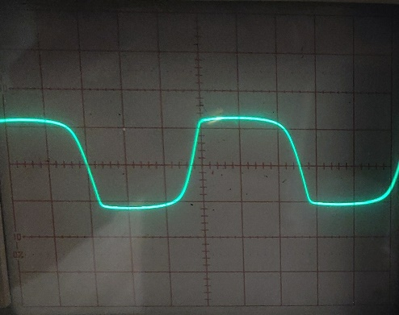

**Circuit 2:**

The input waveform:

With and Without the LED

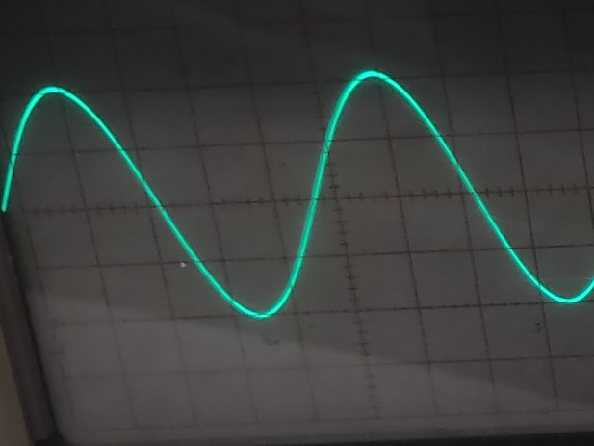

The output waveform:

With LED Without LED

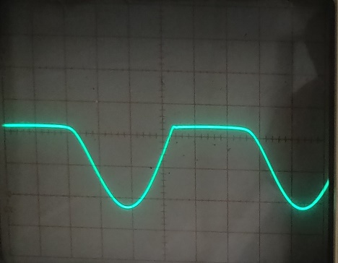 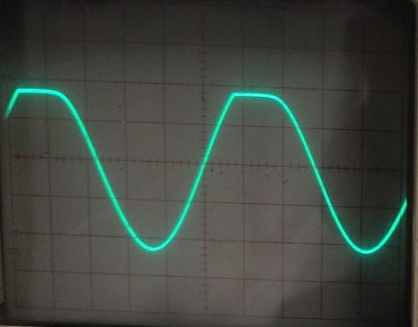

|  |
| --- |
| Cut-in Voltage of LED |
| ≈3.1V |

**Data Analysis**

From my results I observed that the diode was causing a cut-in voltage that was clearly being displayed on the oscilloscope where the sin-wave appears to have the top and bottom of the waves slightly cut off when the 2 diodes where connected. The cut-in voltage of the diodes was estimated to be 0.7V which matched that of a silicon diode cut-in voltage evidence provided in the image below.

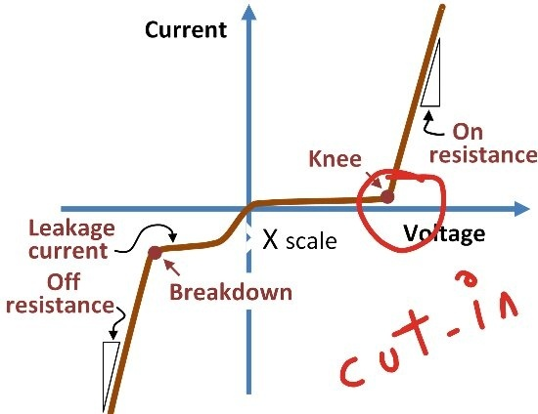

For the second circuit I observed that the output waveform with the LED instead of the diode, the whole top of the sin-wave was cut off completely as the LED was causing a cut-in to the input voltage. I estimated the cut-in voltage of the LED which was 3.1V which matched that of a normal cut-in voltage of an LED.

Without the LED the cut in voltage of the diode that was in forward bias showed a cut-in voltage on the sin-wave that was being displayed on the oscilloscope. The cut-in voltage was on the top of the sin-wave which confirms that it was in forward bias.

Based off my results, I’m able to conclude that the cut-in voltage for a silicon diode is 0.7V while the cut-in voltage for an LED is 3.1V. I also observed the different input and output waveforms for circuit 2 which matched what I would expect from a circuit with an LED and without and LED.

**Conclusion**

Overall, the above analysis and data provided show the observation that the silicon diodes had a cut-in voltage of 0.7V while the cut-in voltage of the LED is 3.7V which was verified by the graph of the cut-in voltage on the oscilloscope. The expected waveforms for the diodes matched that of my results. In conclusion the experiment verified that the silicon diode has a cut-in voltage of 0.7V and the cut-in voltage of the LED is 3.7V.

**References**

<https://www.scribd.com/doc/12936752/Physics-222-Ohm-s-Law-Lab-Report>

<https://www.circuitlab.com/>

https://electronicsclub.info/circuitsymbols.htm

<https://www.quora.com/Why-the-cut-in-voltages-of-silicon-and-germanium-different>

<https://www.quora.com/What-is-the-cutin-voltage-of-a-diode>

https://en.wikipedia.org/wiki/LED_circuit